## Trunk Based Development

### Development Workflow

1. Branch

The Developer creates a topic branch (i.e a new feature, a bug fix for a feature or a release, a hotfix for a release) from the trunk branch (e.g. master)

1. Commit   
   Save the change to the topic branch
2. Push  
   When the change has been developed (e.g. code and unitested), push it from the developer’s local repo into the origin.
3. Pull request  
   Raise a request to Pull the changes from the topic branch to the trunk branch (i.e. master)

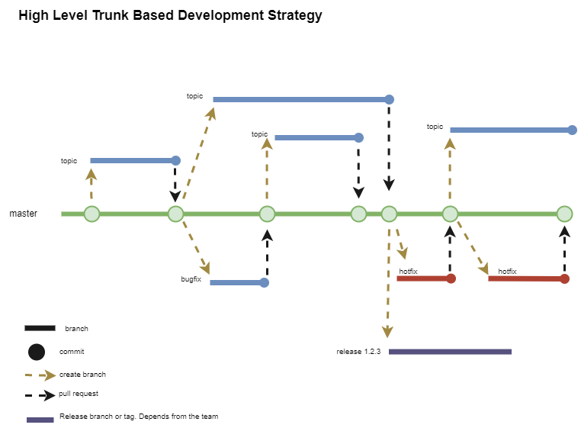

### Naming Conventions (Branches)

* **Topic branch**: {WorkItem.Type}/{WorkItem.Identifier}-{WorkItem.ShortTitle}

| **where:** |  |  |
| --- | --- | --- |
|  | {WorkItem.Type} | Type of change being developed [in lowercase] - values: feature, bugfix, hotfix |
|  | {WorkItem.Identifier} | Change Identifier, e.g. 105247 |
|  | {WorkItem.ShortTitle} | Short title - either removing space characters or replacing them with another character, i.e. an underscore character, e.g. SQLFirewallRules, SQL_Firewall_Rules |